Workshop for Edcamp 2018
The University of Languages and International Studies
21 April, 2018

1. Title: Applying Critical Thinking Skills: Examples from the EFL Classroom
Room:
Time: 120 minutes (1.00 - 300)
Presenters: Dr. Ramin Yazdanpanah & Tran Thi Thu Trang, Thai Nguyen University
Registration link: https://goo.gl/forms/N7HLRqezBMjccKec2
Integrating and applying critical thinking skills is central to English language teaching in the 21st century (Rezaei, et al, 2000). Students must be able to move beyond being passive consumers of information, to developing their own ability to interpret complex understandings about the world (Oliver & Utermohlen, 1995). Therefore, teachers must be able to explicitly model and guide students in applying critical thinking within their own coursework and subject matter (Willingham, 2007). This workshop will provide two examples of critical thinking instruction within a tertiary context: a Teaching Methodology course and an Intercultural Communications course. The first presenter will discuss how she applies whole-class discussion activities to help students generate and answer critical questions concerning teaching methodology. The second presenter will discuss activities that move students beyond the memorization of cultural facts, and dos and don'ts, to higher order thinking skills to analyze and challenge cultural stereotypes and biases through both in-class as well as online multimedia projects.
The presenters will engage participants in activities that build students’ confidence and linguistic ability to discuss, reflect, and share critical and more complex perspectives of the world and themselves.

2. Title: Developing growth mindset in language learning environment
Room:
Time: 120 minutes (1.00 - 300)
Presenters: Dr. Hoàng Thị Hạnh, the University of Languages and International Studies
Registration link: https://goo.gl/forms/N7HLRqezBMjccKec2

Motivation is one of the most important factors contributing to language learning success. Developing a growth mindset has been found to create motivation, help learners proactively face challenges, and be persistent in achieving their goals. This session aims at introducing theory and practice relating to the implications of growth and fixed mindset. Participants will have chance to explore their existing mindset, to learn and practice strategies to nurture an enabling environment for learning and developing creative and reflective thinking in a collaborative environment.
3. Title: Improving Students’ Learning Outcomes Through Service Learning
Room:
Time: 120 minutes (1.00 – 3.00)
Presenters: Jeanie Cook, MA TESOL
English Language Fellow, The US Embassy
People’s Police Academy, Hanoi
Registration link: https://goo.gl/forms/N7HLRqezBMjccKec2
In this workshop, participants will learn what service learning is; its benefits for students, teachers, learning institutions and the community; and kinds of projects that can be done. Then everyone in the workshop will have the task of designing a service learning project with a small group while thinking about the kinds of projects, goals for students, the skills to focus on and the learning assessment of students. I will provide steps for starting the project. By the end of the workshop, participants should have many ideas and plans for implementing service learning with their students.

4. Title: Teaching Writing: Thoughts and Ideas for Teachers
Room:
Time: 120 minutes (1.00 – 3.00)
Presenters: Veronica Moermond, M.A., M.Ed., RPCV
English Language Fellow, US Embassy, Ha Long University, Uong Bi.
Registration link: https://goo.gl/forms/N7HLRqezBMjccKec2

As teachers, we sometimes forget that which we already know, so a little refresher is useful. The presenter will begin with discussing the five types of anti-writers that are common in most English classrooms. Teachers will begin to reflect on why students find writing boring and what the teacher audience has done in their own classrooms in order to combat this. Journal writing is demonstrated with a creative writing prompt, and the presenter will then share as an easy way to “grade” journals. News articles, picture caption contests, and short story writing with photo prompts are discussed and demonstrated. Emotion poetry is demonstrated and poetry is discussed as a way to get students thinking about writing using sensory images. Basic writing templates are given as a way to help reluctant and struggling writers. Finally, a video opinion writing prompt is shown as a way to help inspire students into wanting to write.

Presenters:
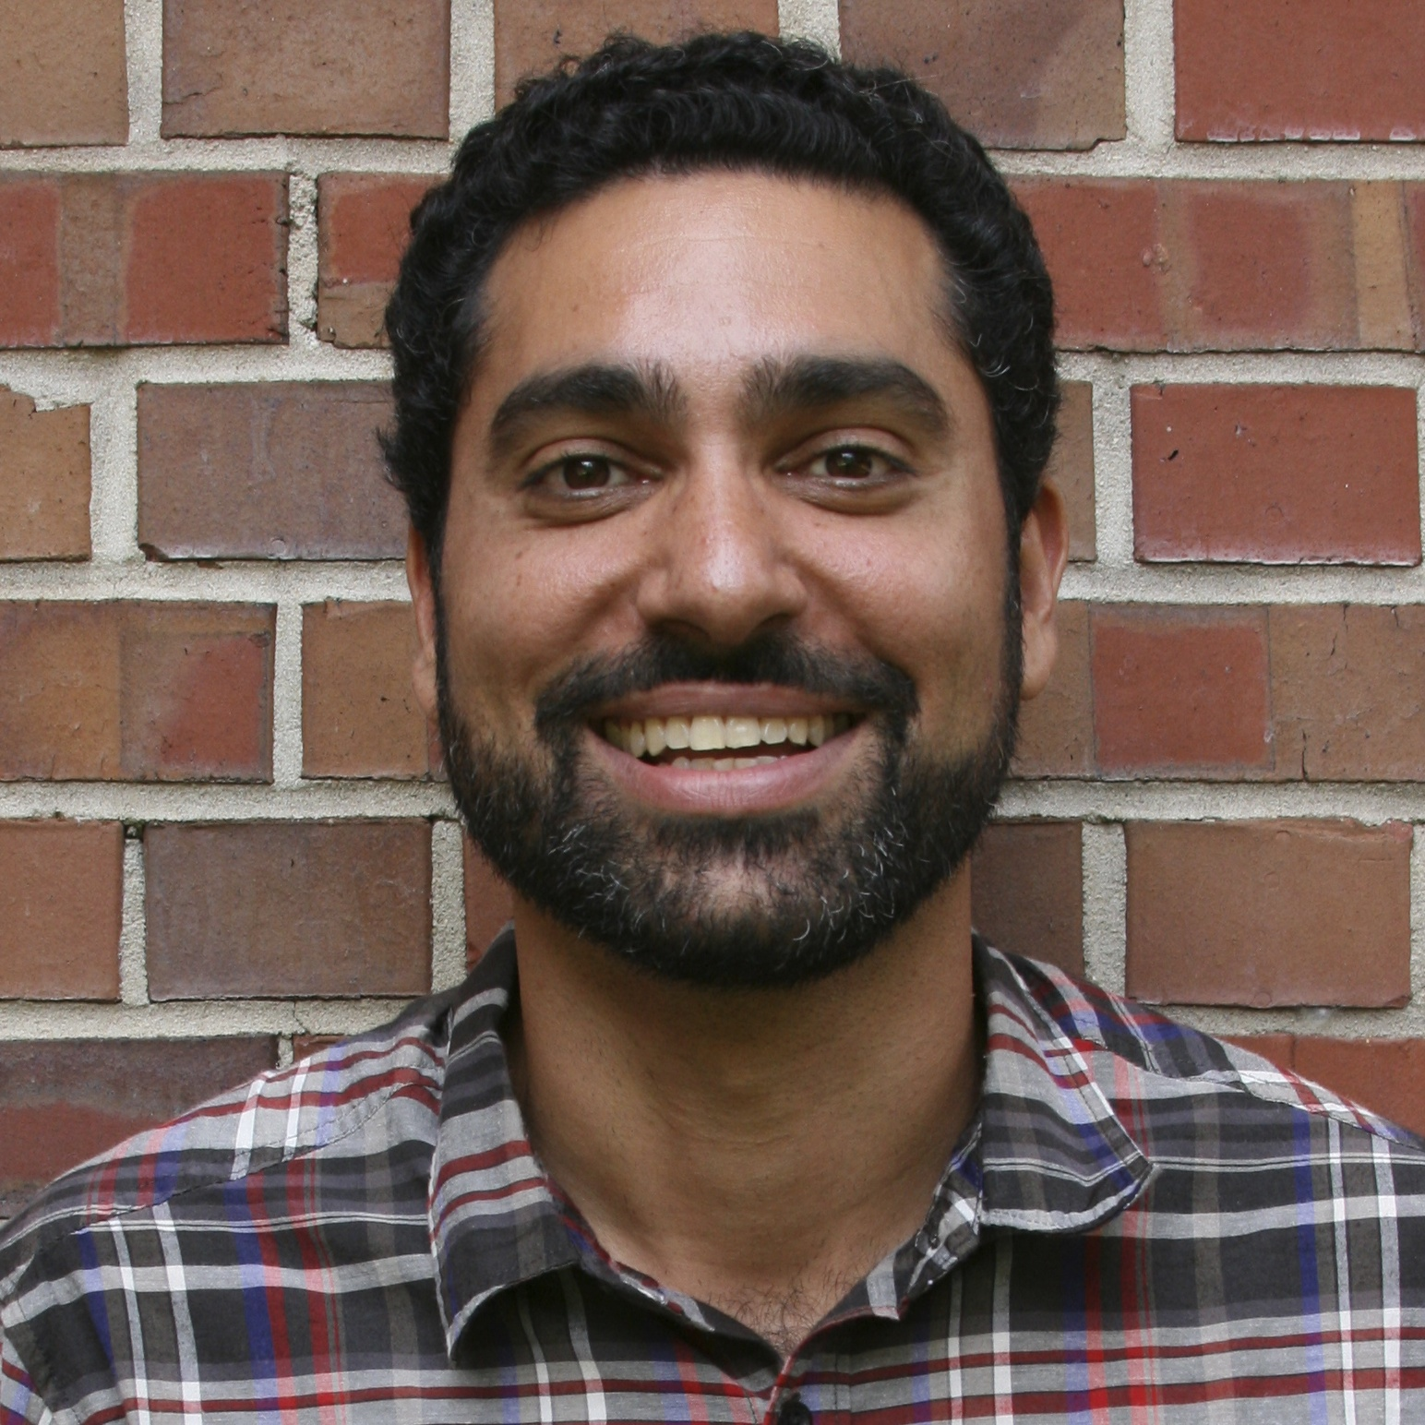
Dr. Ramin Yazdanpanah holds a doctorate from Florida State University for his research analyzing the developing intercultural competence of pre-service English language teachers. Dr. Yazdanpanah has extensive experience as an English language teacher, teacher educator, and program coordinator, and is currently serving as an English Language Fellow in Vietnam at Thai Nguyen University. He is also currently serving as Chair of the Intercultural Communication Interest Section (ICIS), TESOL International.

Ms. TRAN, Thi Thu Trang is the Deputy-head of English Department at Thai Nguyen School of Foreign Languages. Her main responsibilities and interests, apart from teaching university students, are training high school teachers of English, designing and evaluating teaching materials, doing research related to language teaching, setting up online courses using learning management systems, and organizing extra-curricular activities for students. Ms. Tran received her master’s degree in teaching methodology from the University of Languages and International Studies – Vietnam National University in 2012 and a Bachelor of Arts in English from Thai Nguyen University of Education. In 2016, she became a member in the Community of Practice under the Lower Mekong Initiative Project. Currently, she is involved in community activities for students and high school teachers. Email: tranthutrang.sfl@tnu.edu.vn

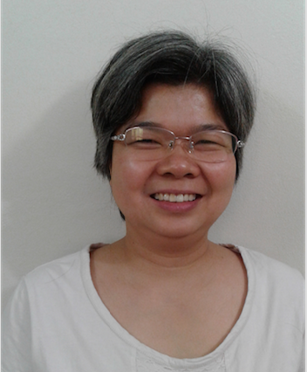
Dr. Hoàng Thị Hạnh is a lecturer at University of Languages and International Studies, VNU. She completed her MA-TESOL program at the University of Queensland, Australia in 2005. She obtained her PhD degree from the same university (UQ) in 2013, studying Vietnamese students’ group work communication. She has extensive experience in EFL teacher training. She believes that building trust, respect and valuing diversity instead of hierarchy are the keys to success in teacher training. Her study interests include intra/intercultural communication and EFL methodology.

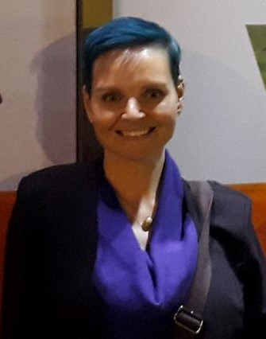
Veronica Moermond has a Masters in English as well as a Masters in Education. She taught high school and college in the U.S. for five years before making her way to Mongolia as a TEFL Teacher Trainer for the U.S. Peace Corps. She spent an additional two years in Ulaanbaatar before making her way south to be an English Language Fellow at Ha Long University in northern Vietnam.

Jeanie Cook received her Master’s in TESOL from the School for International Training in Brattleboro, Vermont with K-12 certification from North Carolina. She has taught in many ESL/EFL venues including K-12 North Carolina public schools, migrant worker farms, universities, community college, Intensive English Programs, and international schools. Her teaching outside of the US has been in France, Japan, Guatemala, Myanmar/Burma, Kurdistan Iraq and Indonesia, this last one as an English Language Fellow at Yogyakarta State University.

